第三章 向量组

知识点：

向量组相关：
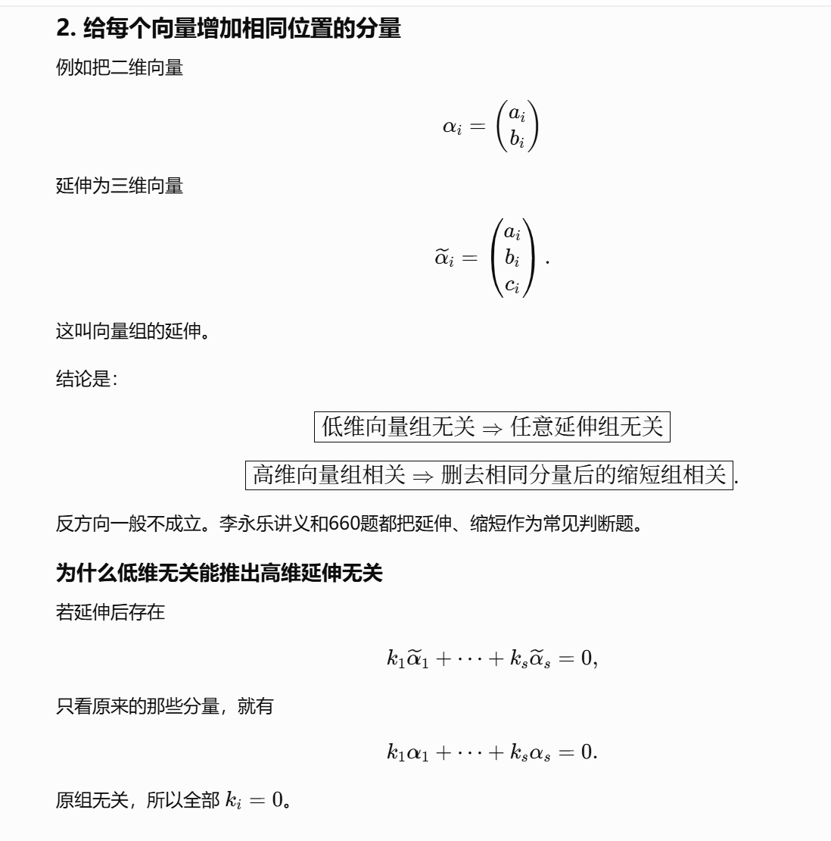
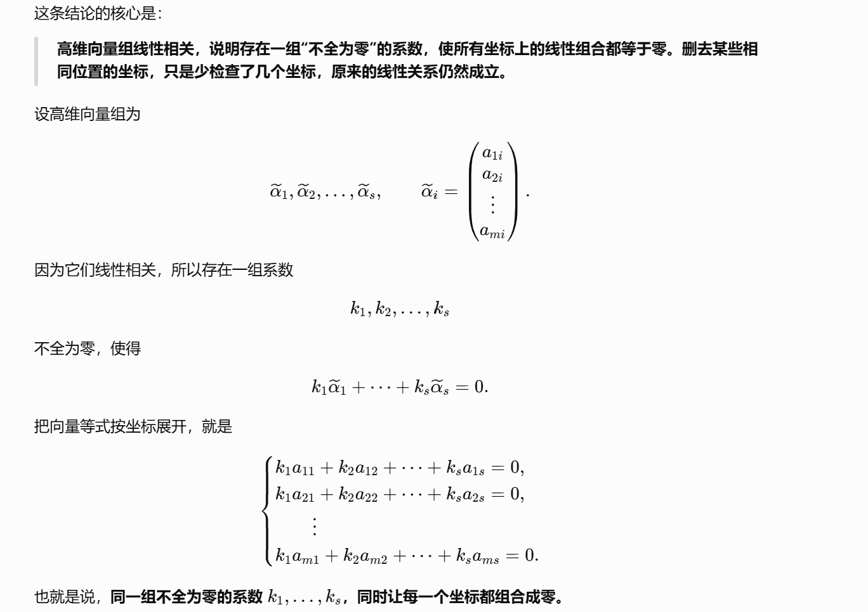
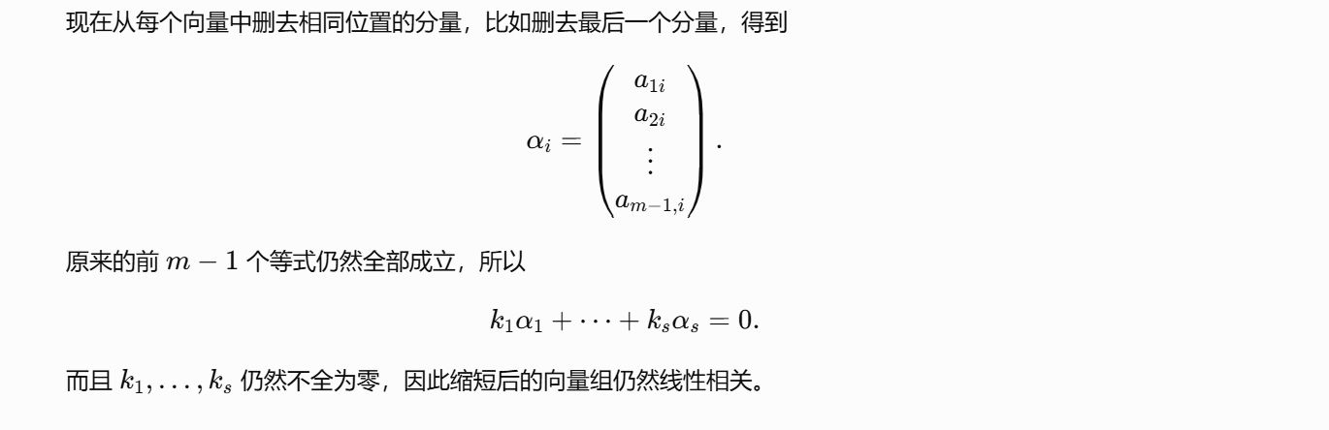
https://chatgpt.com/g/g-p-6a1d6c6f0a408191a175c887909fceb5-xian-dai-he-gai-lu-lun-ocr/c/6a71e3d0-623c-83e8-b2d4-04cee177b26f
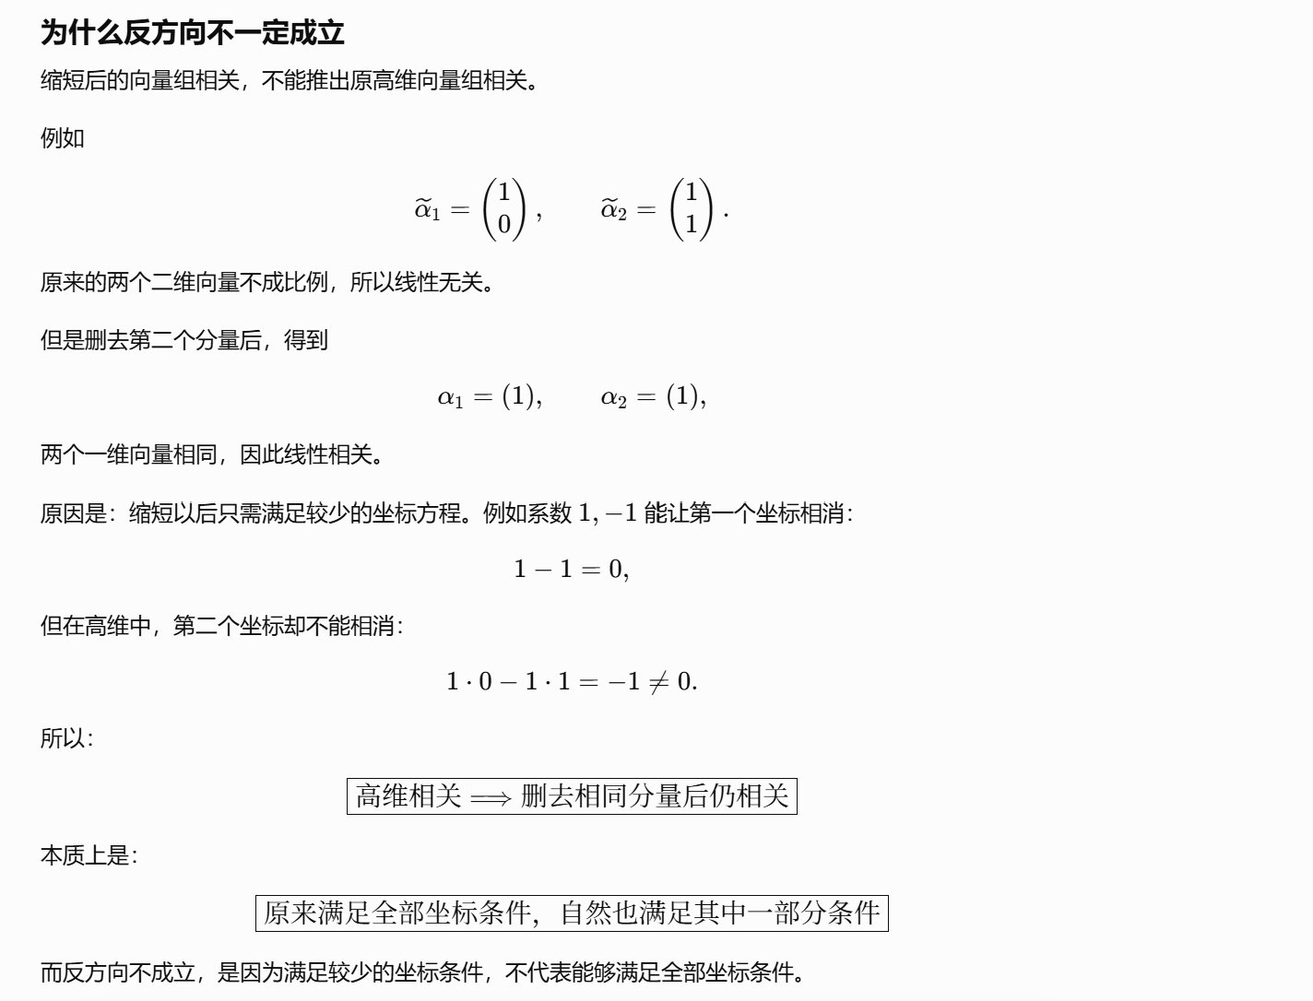

题：

题1：
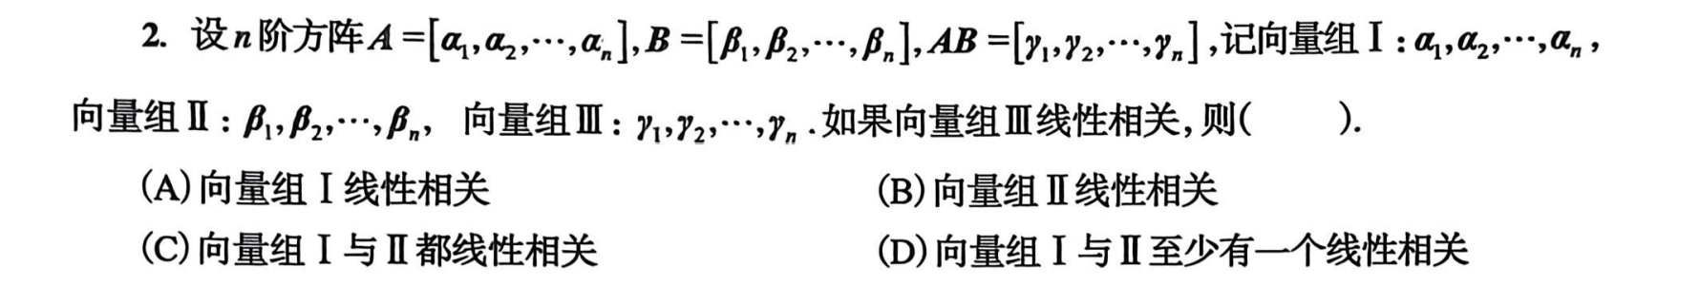
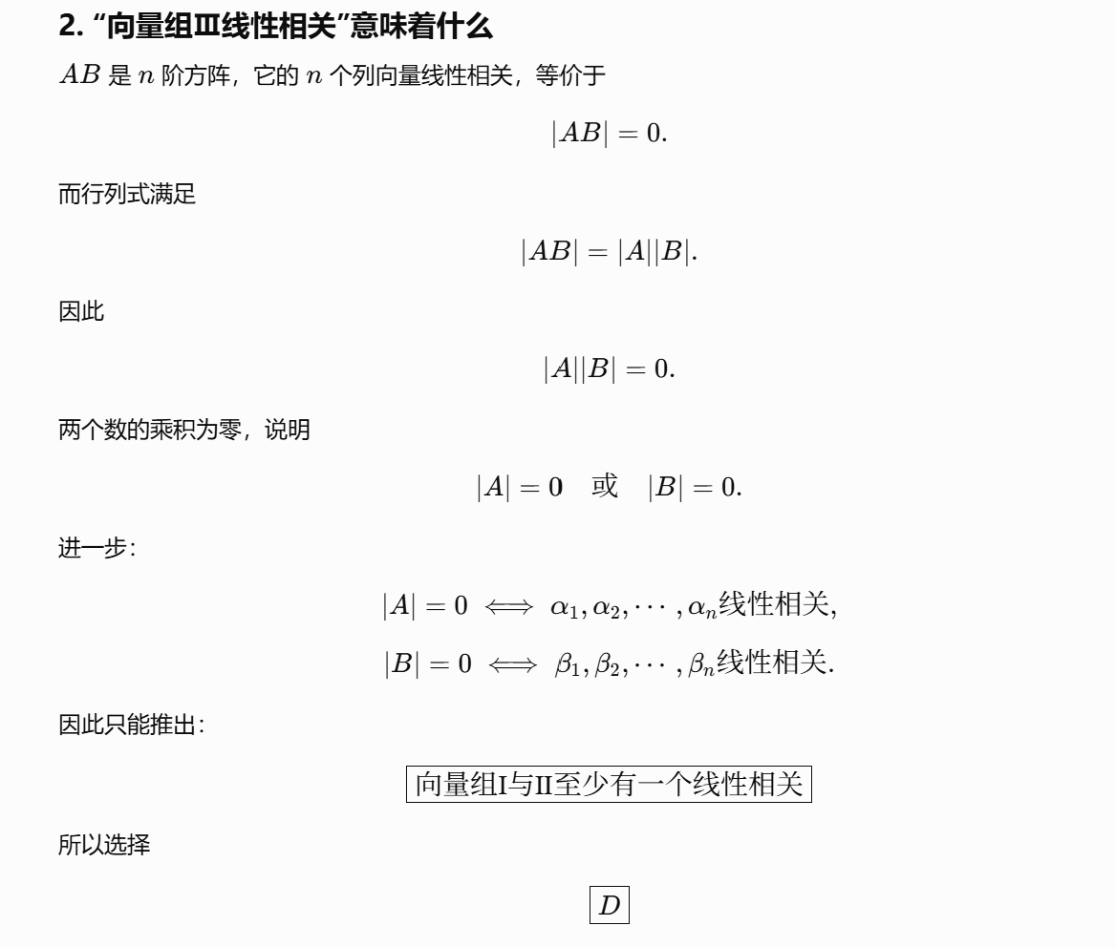
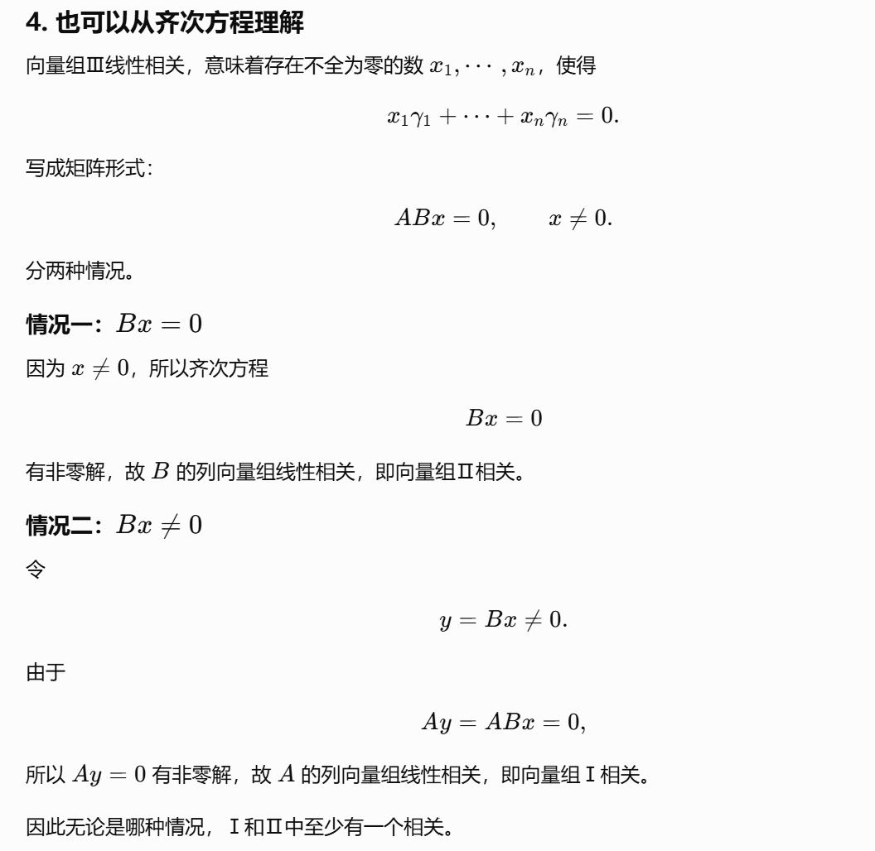
https://chatgpt.com/g/g-p-6a1d6c6f0a408191a175c887909fceb5-xian-dai-he-gai-lu-lun-ocr/c/6a7463ce-7a3c-83ee-ac6b-0195f4a800c7

题2：
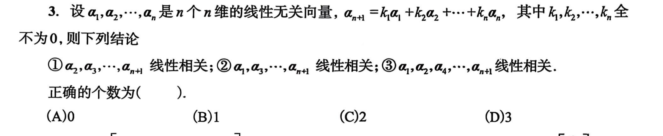
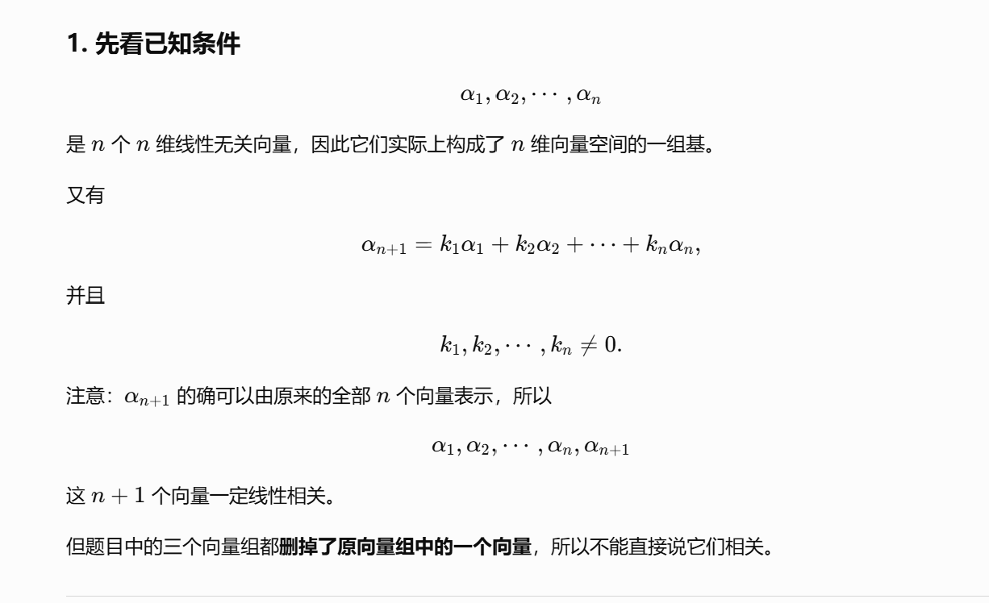
https://chatgpt.com/g/g-p-6a1d6c6f0a408191a175c887909fceb5-xian-dai-he-gai-lu-lun-ocr/c/6a7464f4-e27c-83e9-9f23-21677c442e71

题3：
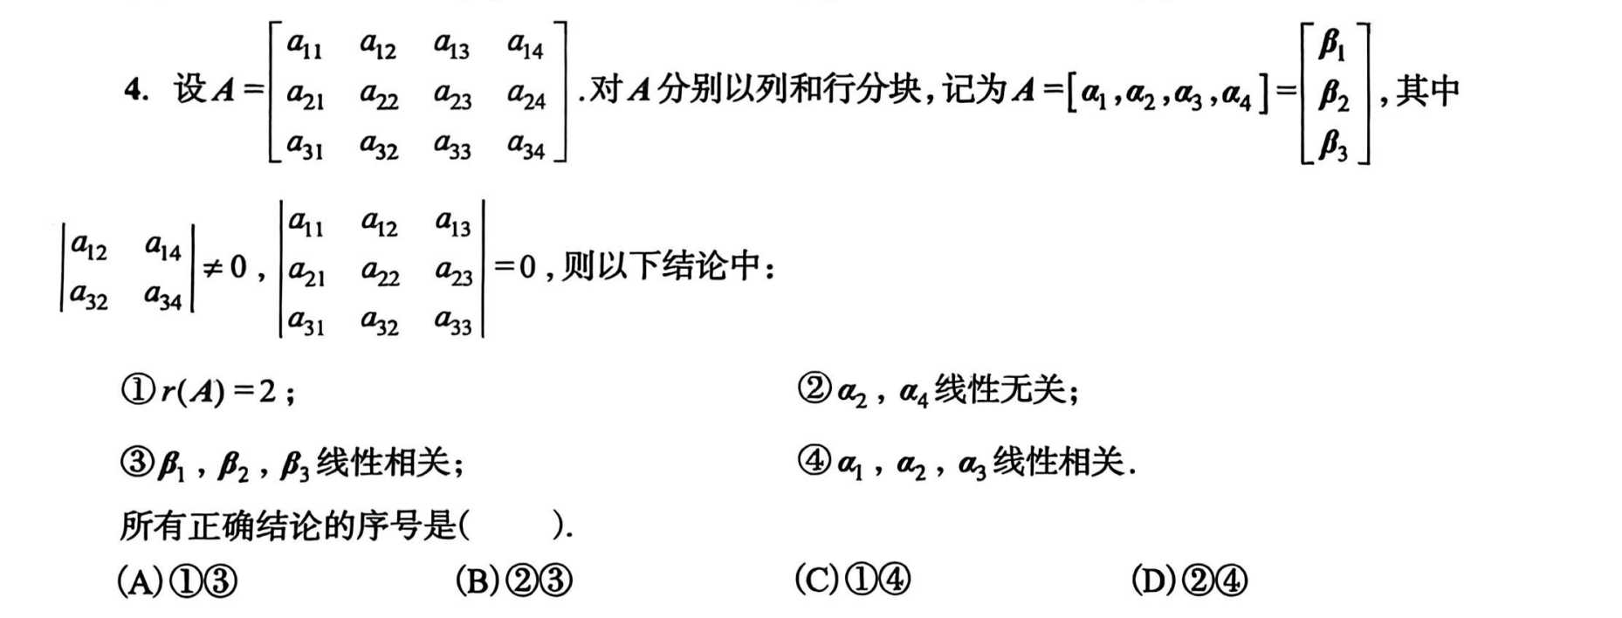
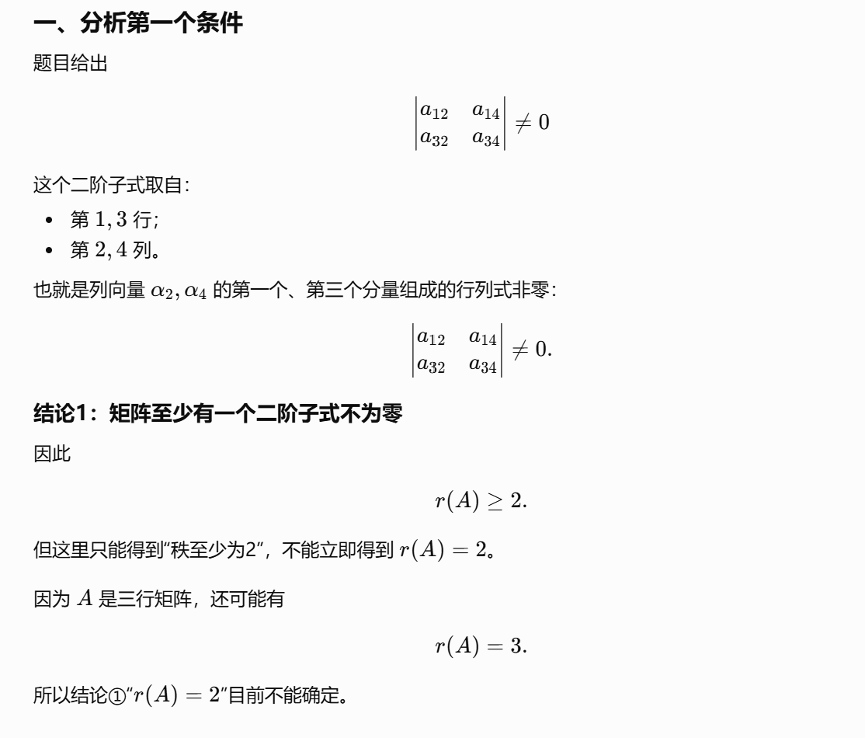
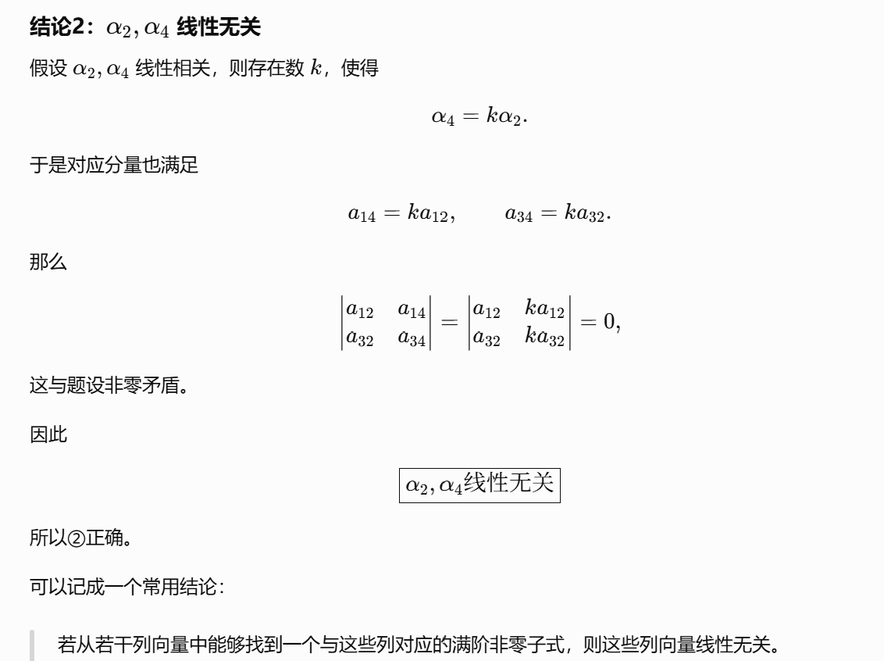
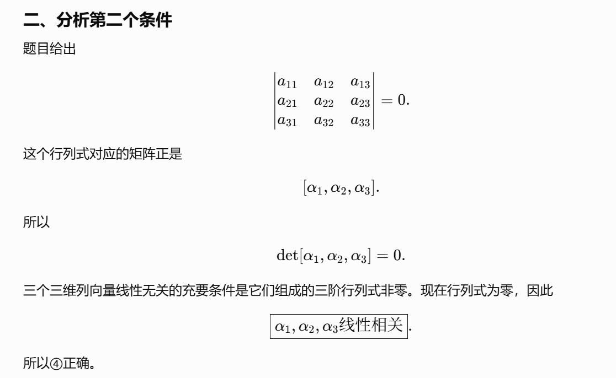
https://chatgpt.com/g/g-p-6a1d6c6f0a408191a175c887909fceb5-xian-dai-he-gai-lu-lun-ocr/c/6a74657b-9b7c-83ee-bda5-f5264a7c69e2

题4：
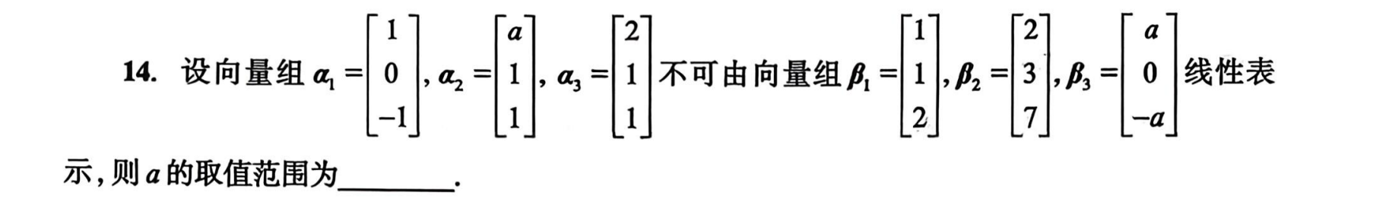
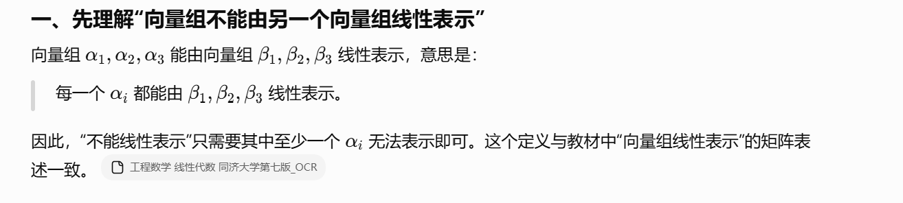
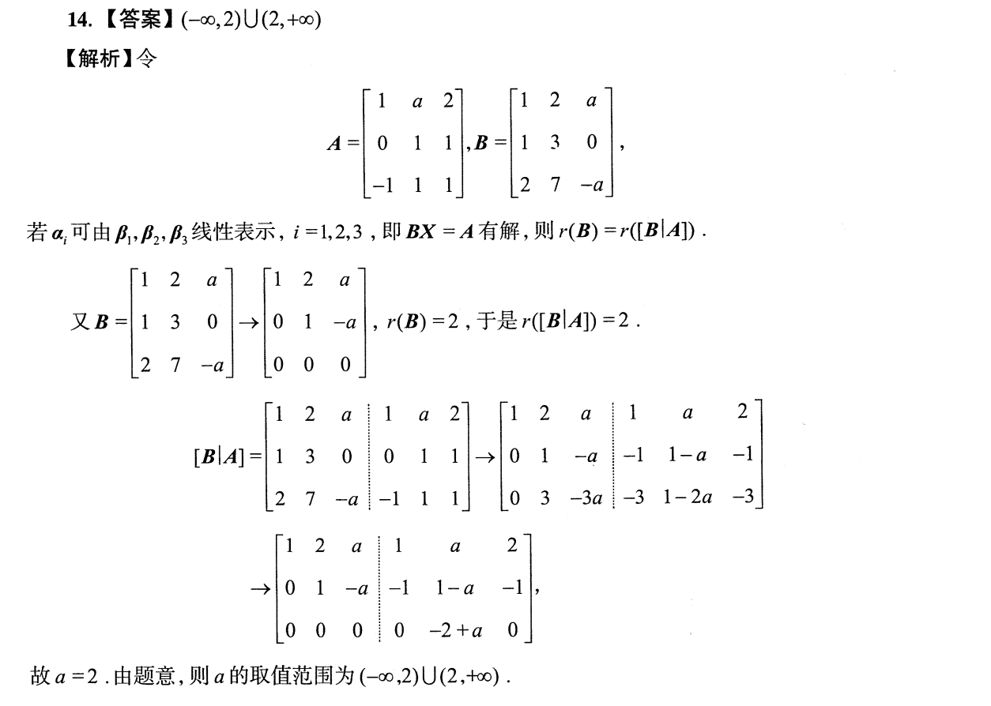
https://chatgpt.com/g/g-p-6a1d6c6f0a408191a175c887909fceb5-xian-dai-he-gai-lu-lun-ocr/c/6a7466ba-b83c-83ee-ba7f-e97c1ad87140

题5：
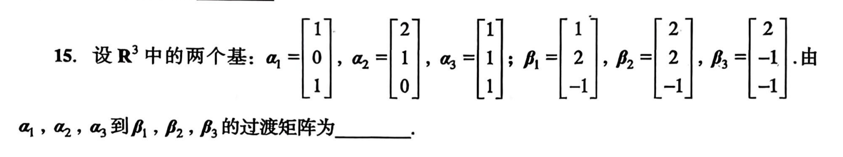
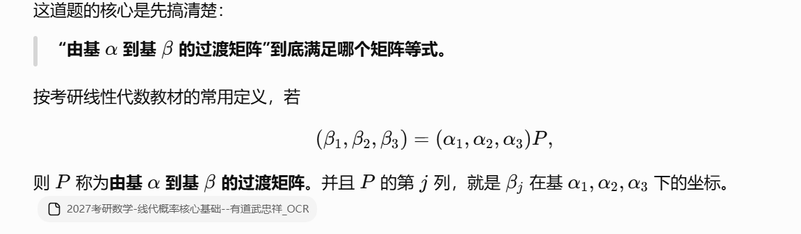
https://chatgpt.com/g/g-p-6a1d6c6f0a408191a175c887909fceb5-xian-dai-he-gai-lu-lun-ocr/c/6a7467c0-8354-83ee-9b15-1277180789f9
|（注：部分内容可能由 AI 生成）

